1. Break the board in half.

2. Separate parts from the bag.

3. Put in the resistors, the direction of them doesn't matter.

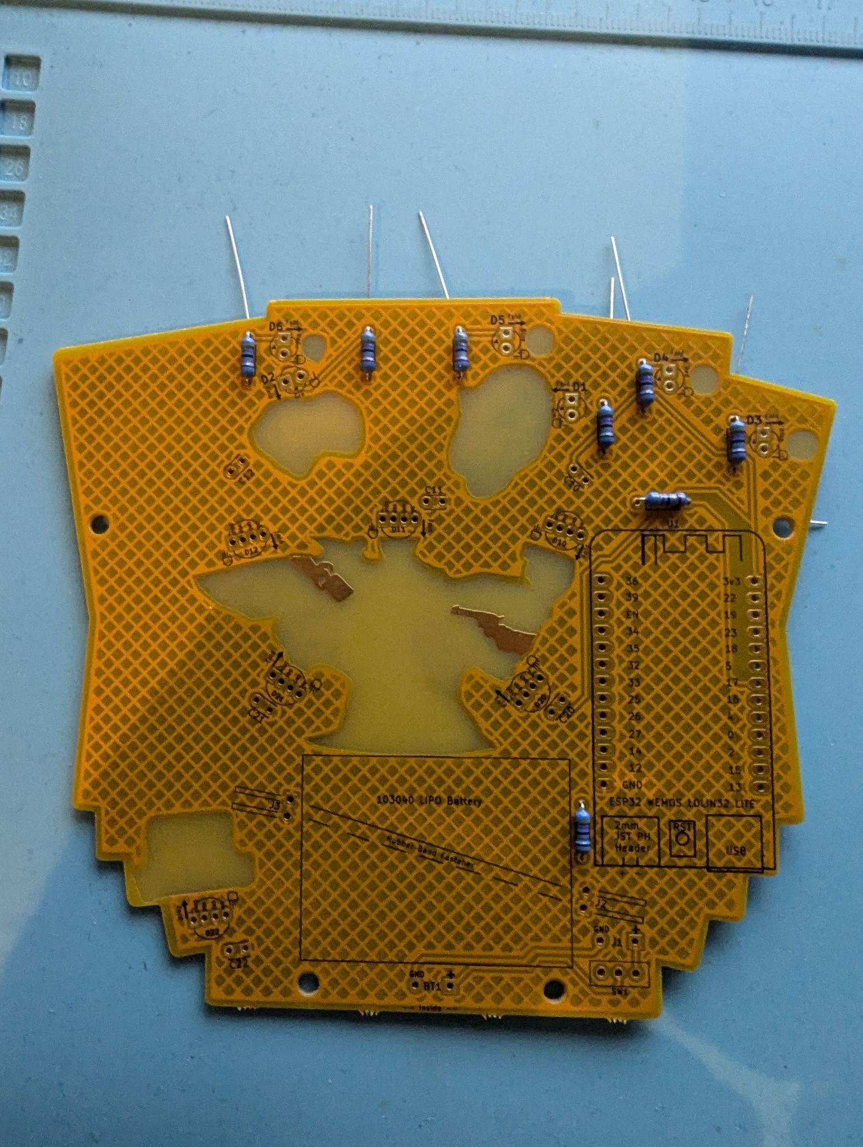

4. Put in the red LEDs with the long pin in the circle hole, bending them with pliers as close to the LED as possible.

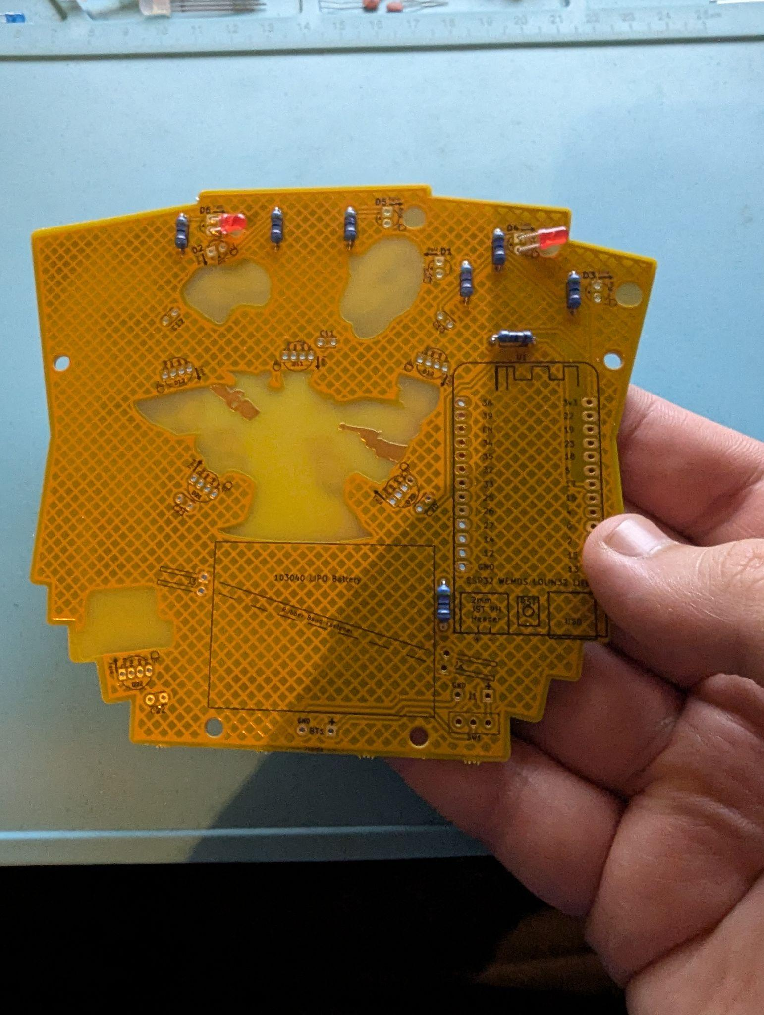

5. Put in the blue LEDs with the long pin in the circle hole, bending them with pliers as close to the LED as possible.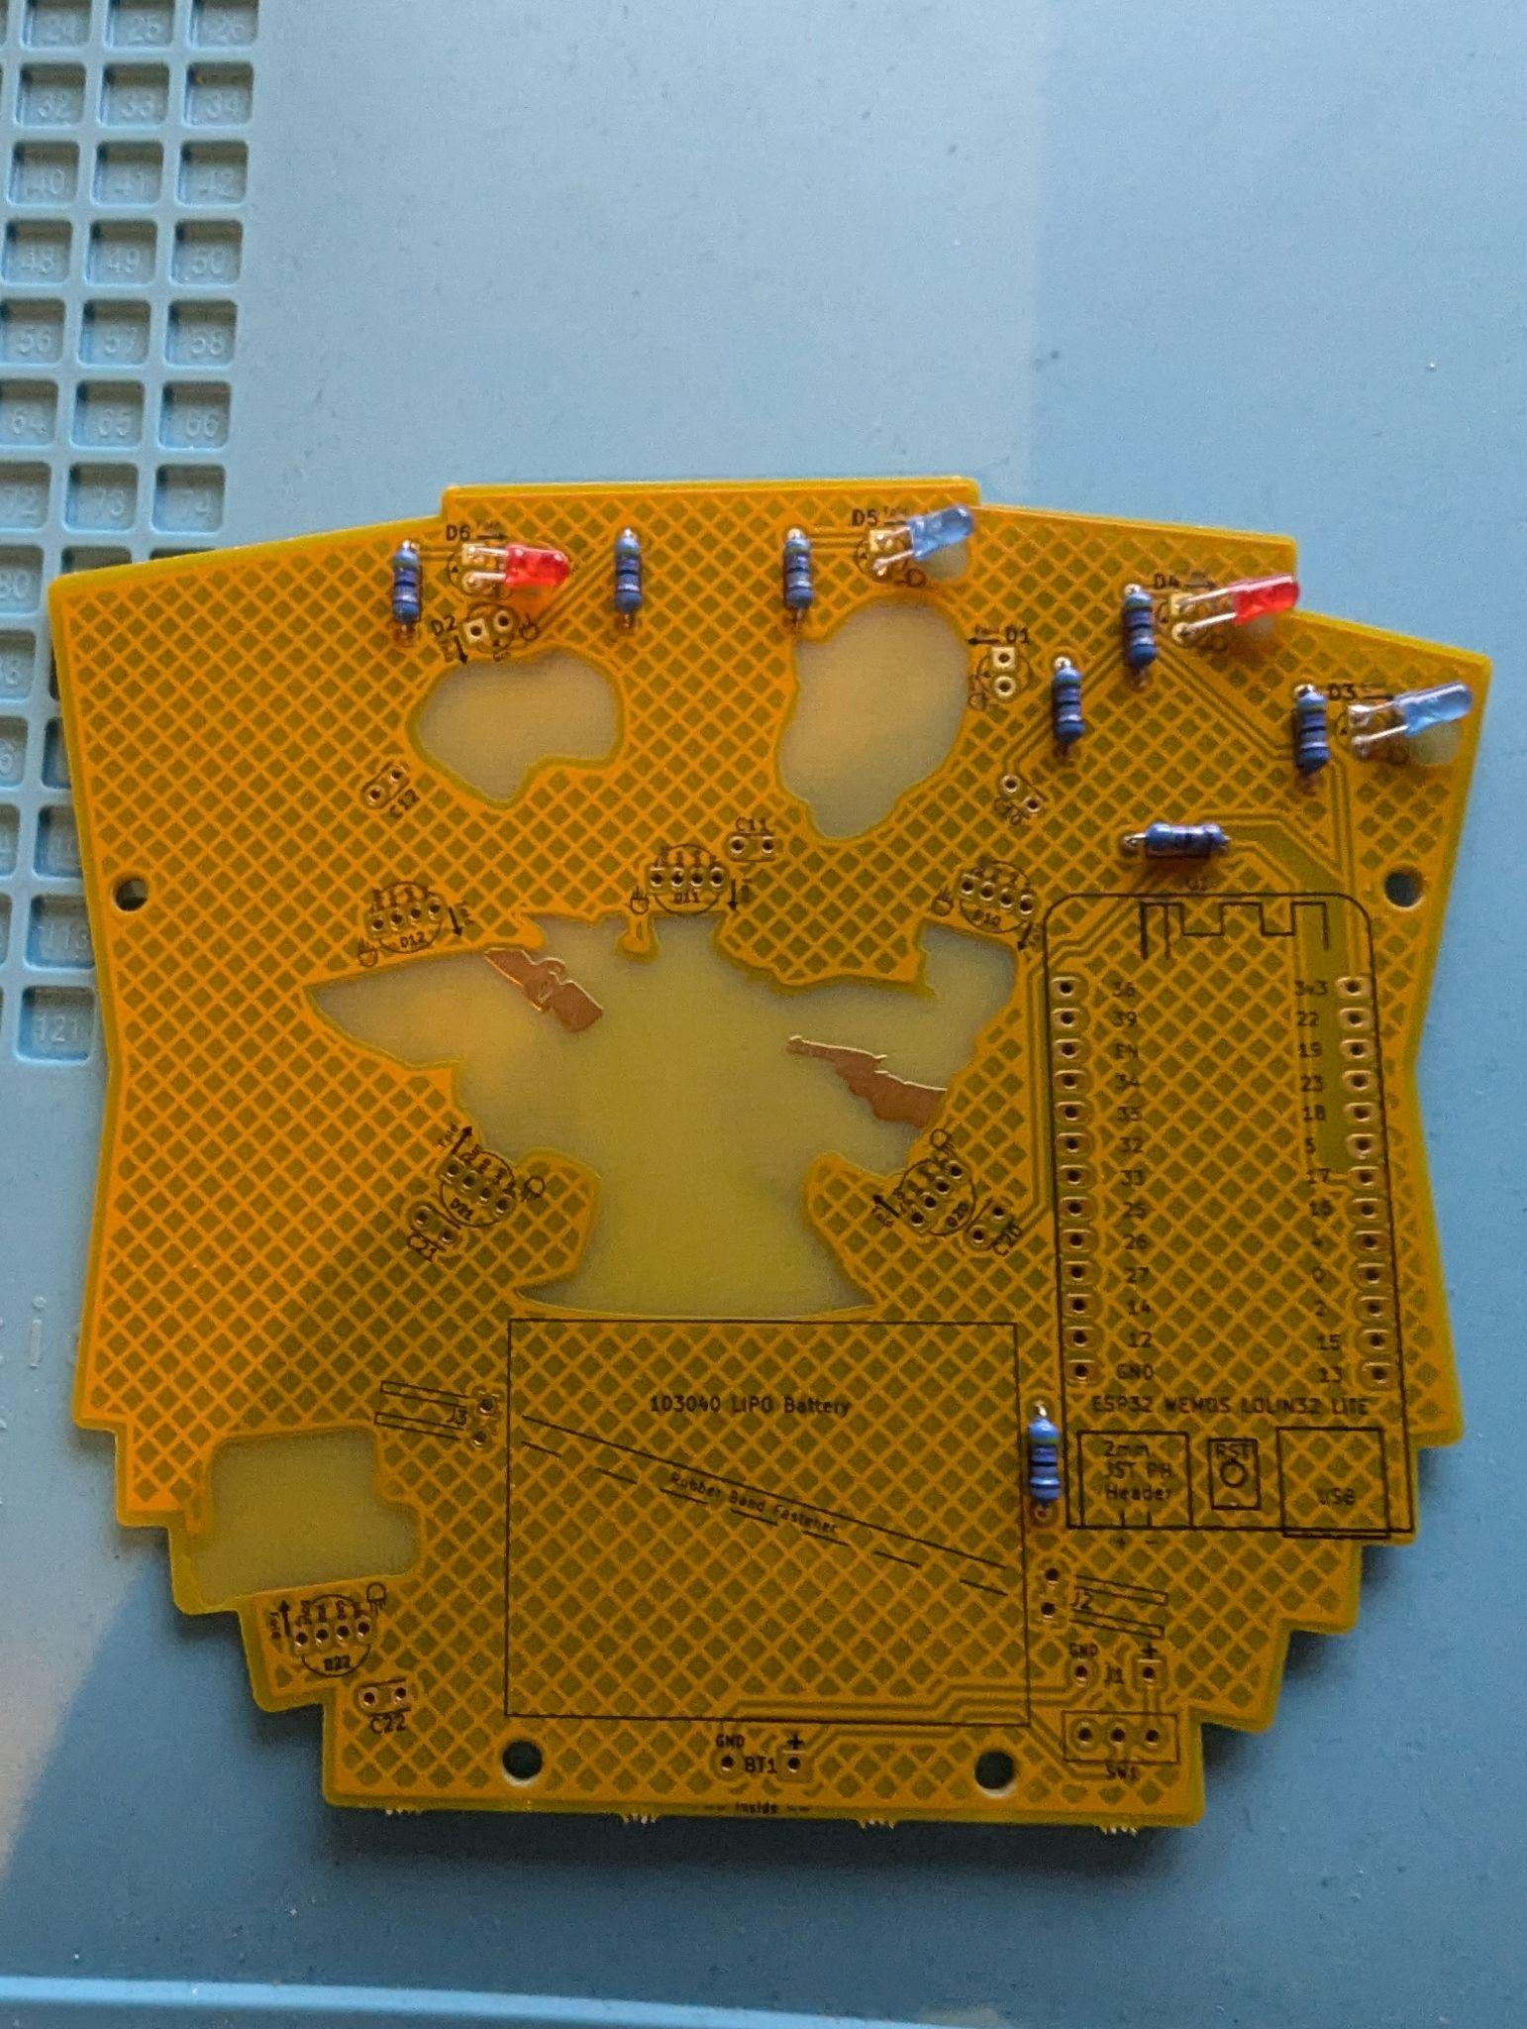

6. Put the white LEDs into the holes marked green with the long pin in the circle hole, bending them with pliers at the flat part of the pins.

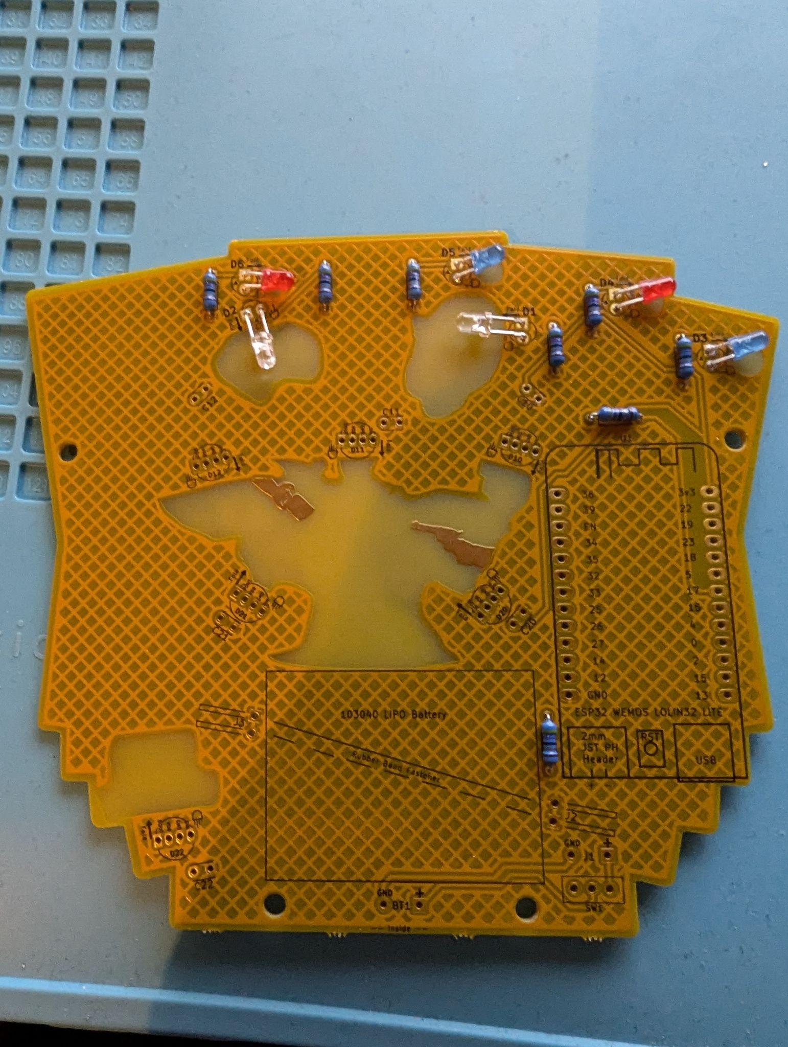

7. Use three of the 4 pin LEDs and put them in the top three holes with the longest pin one away from the square hole, bending them as close to the LED as possible.

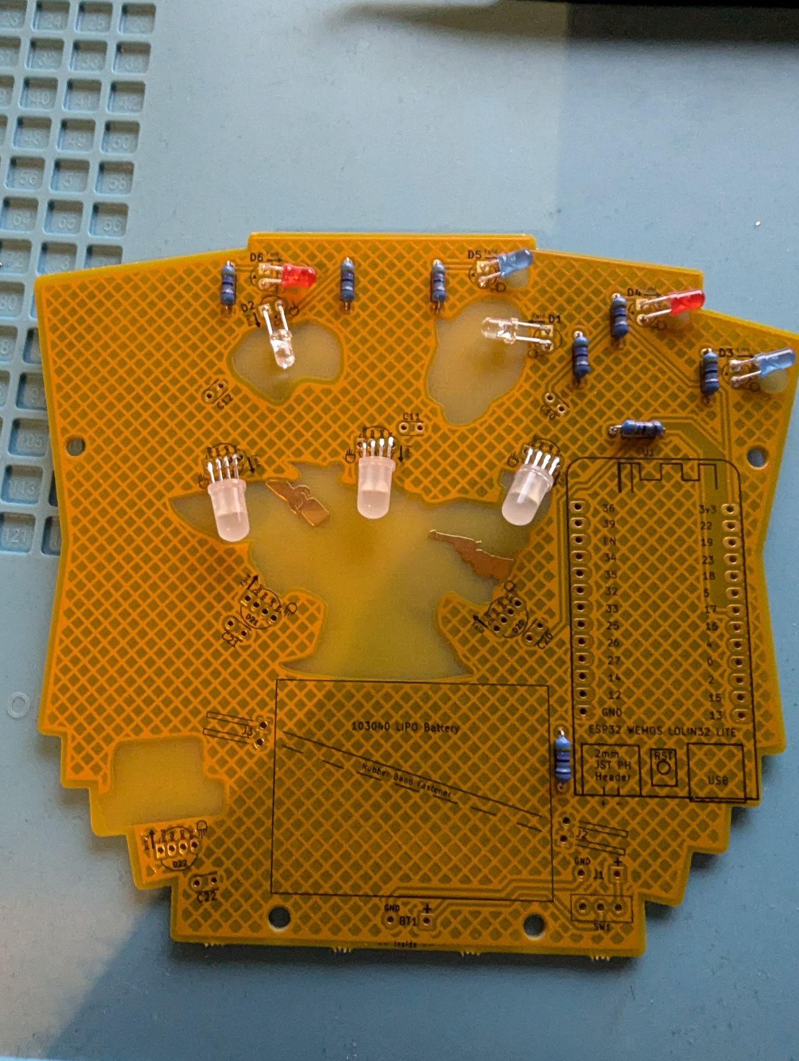

8. Use the other three 4 pin LEDs and put them in the top three holes with the longest pin one away from the square hole, bending them at the flat part of the pins.

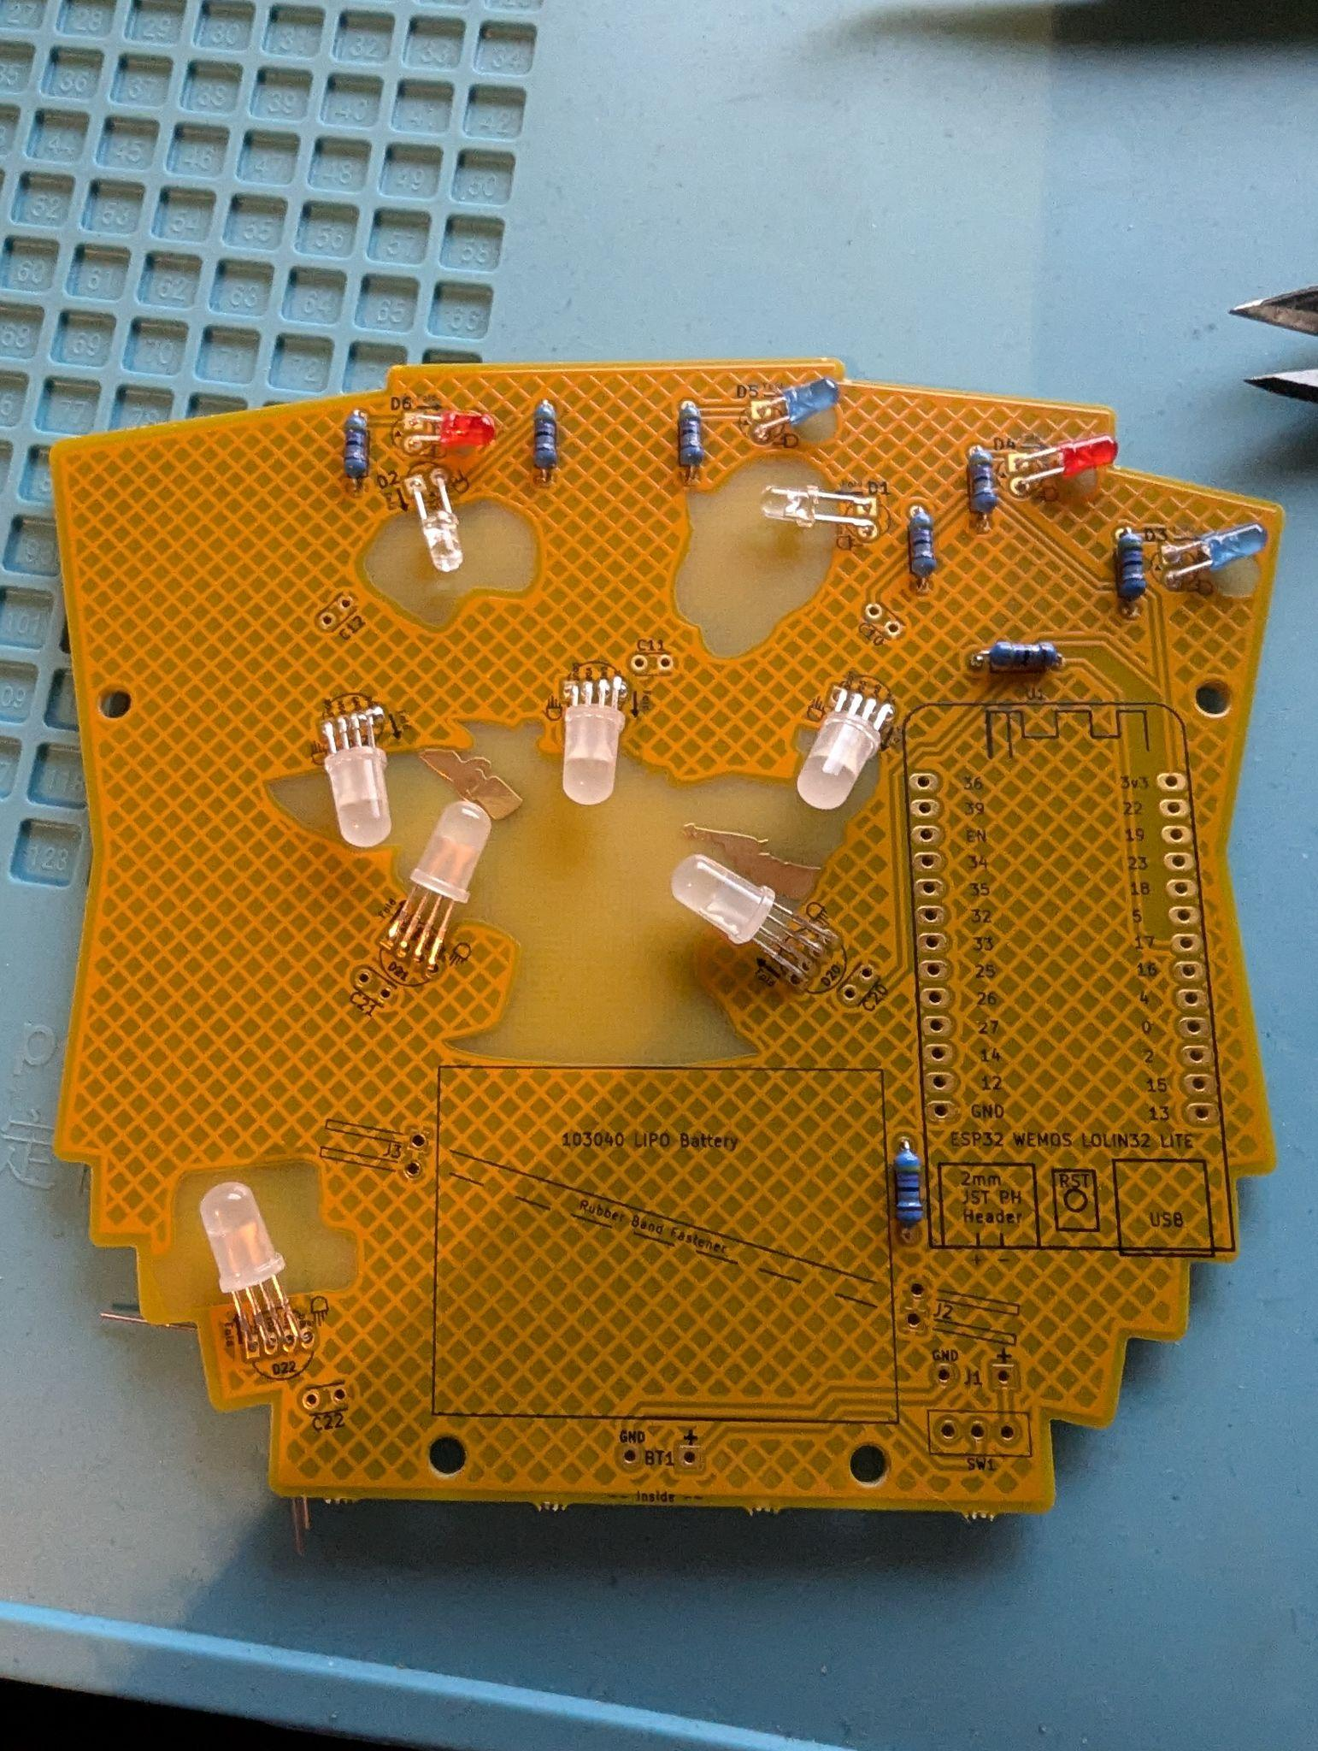

9. Put all six of the ibuprofen looking things into their slots. It doesn't matter what direction they go in. Take a little more time to make sure these have a good connection. 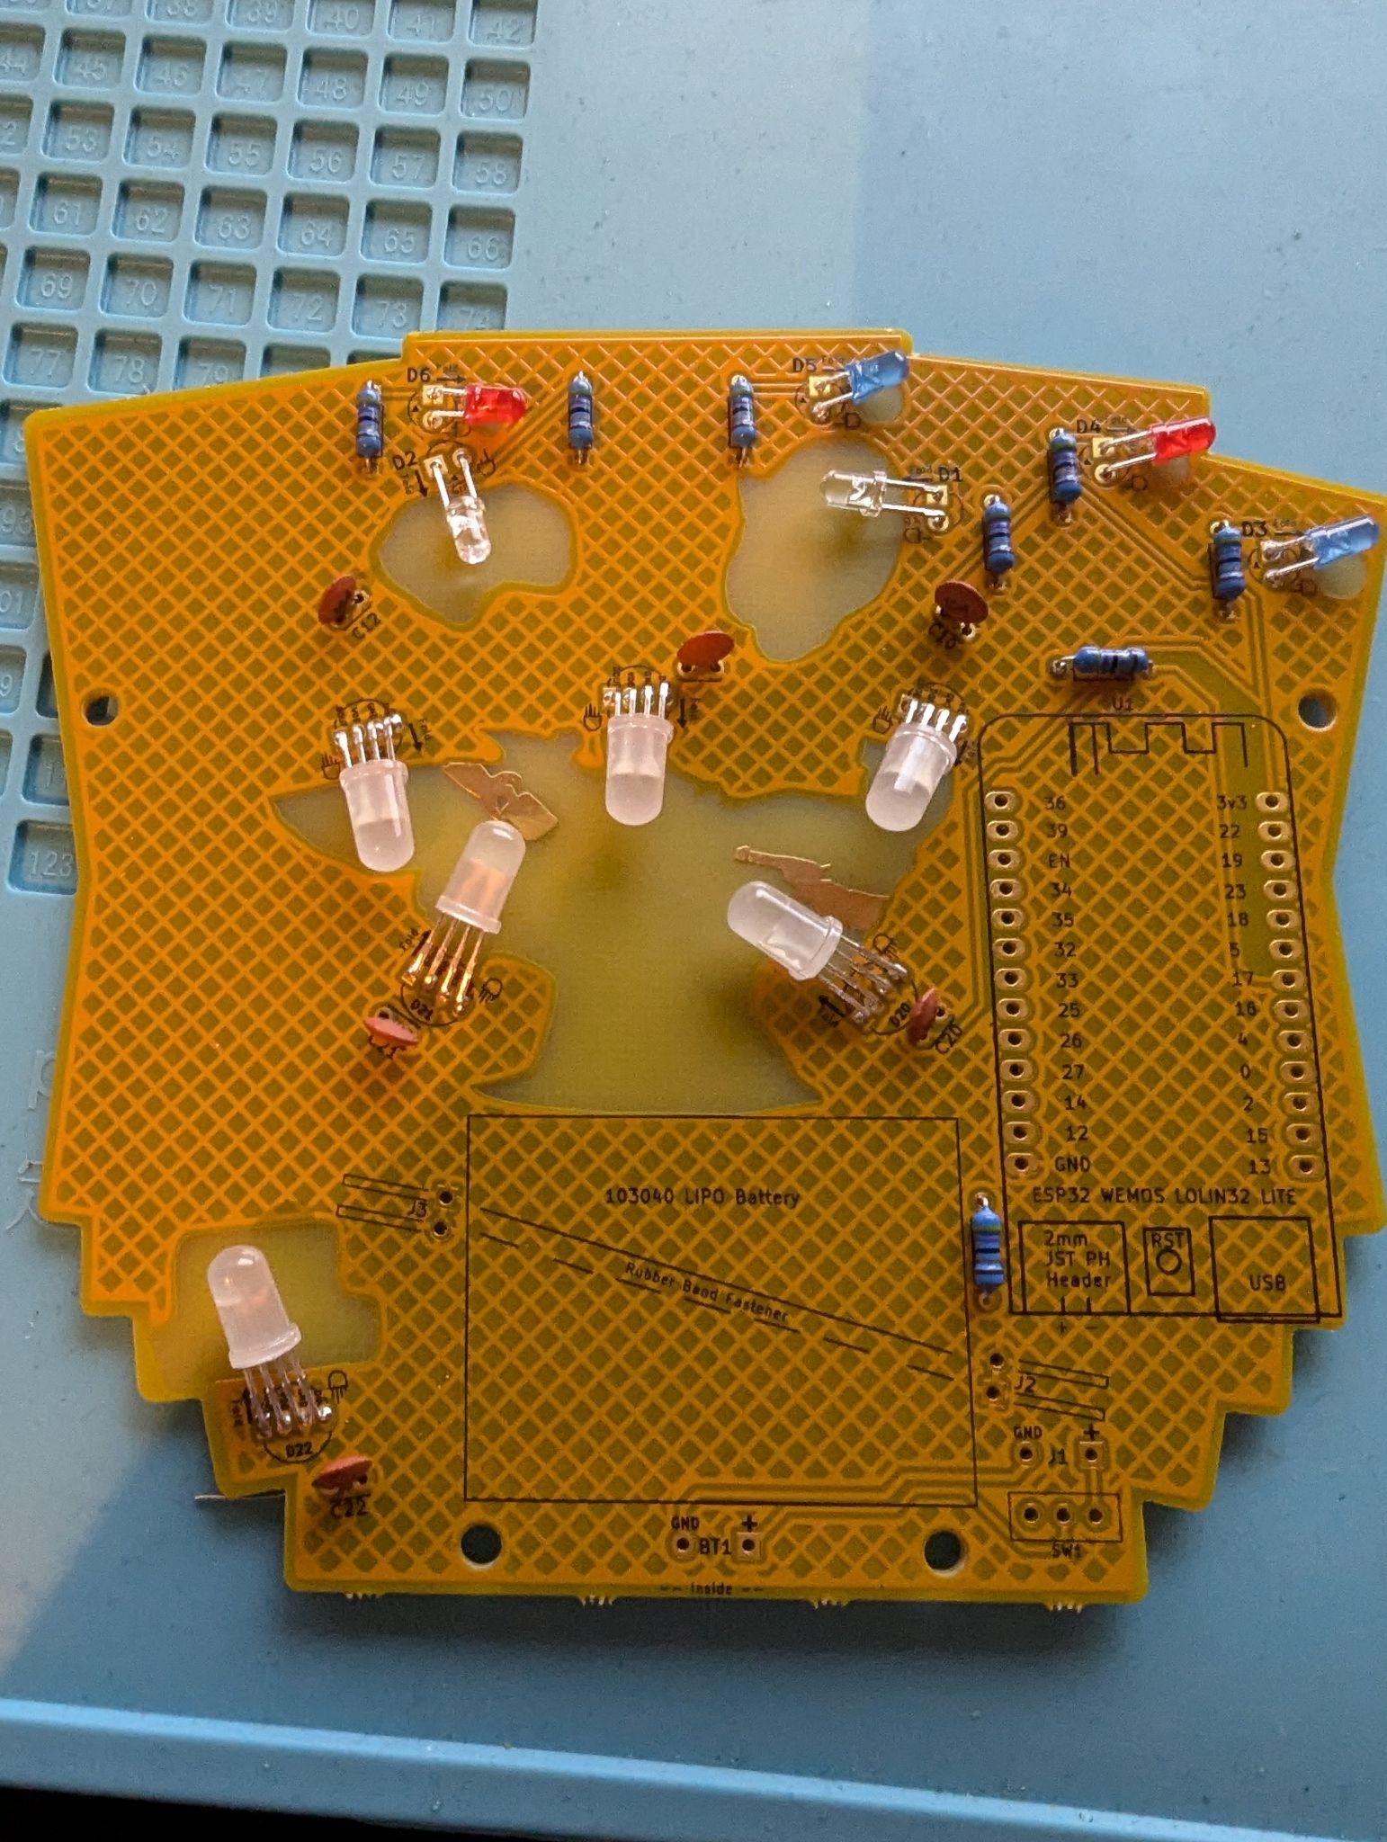

10. Carefully put in the on/off switch, you might have to tilt it a little bit to give yourself enough room on the pins to solder them. 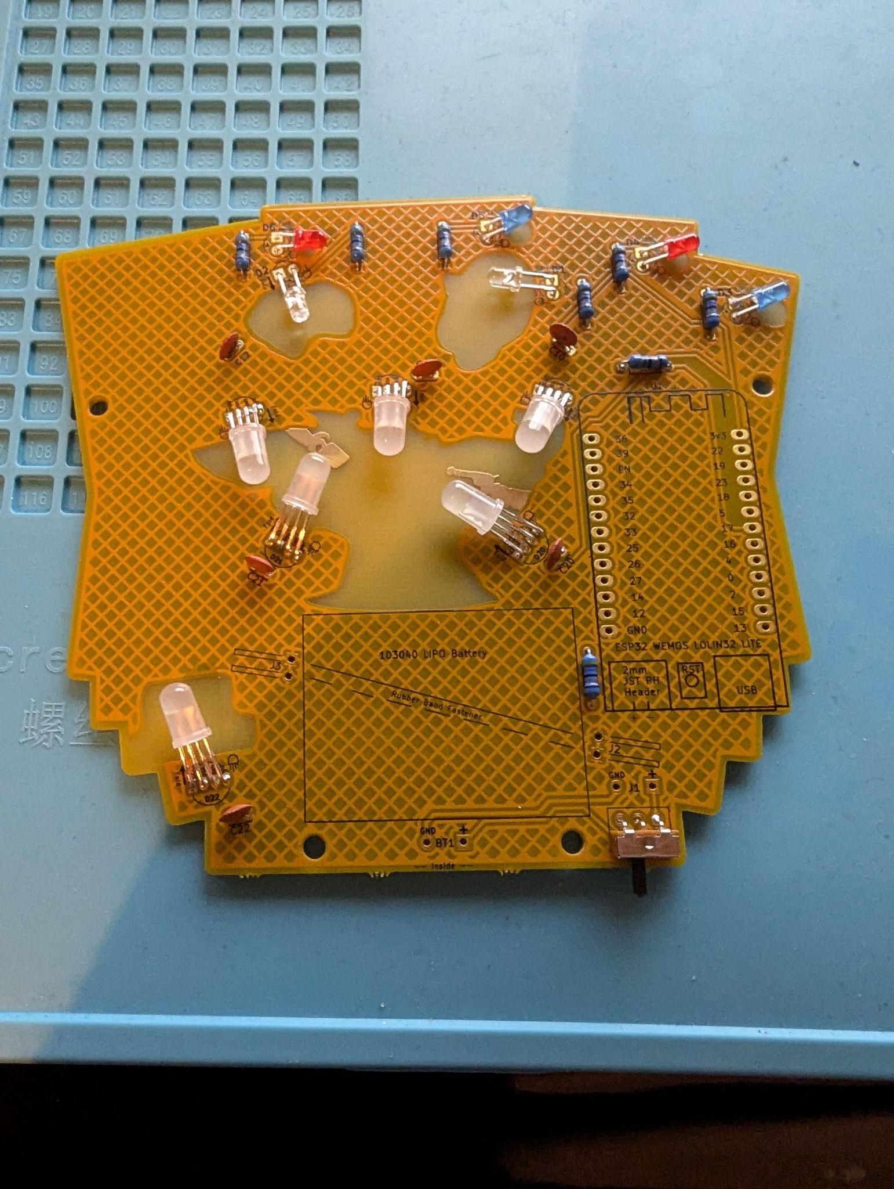

11. Put in the 90 degree pins with the shortest side into the board and then solder it. It's a little tricky, just take your time. 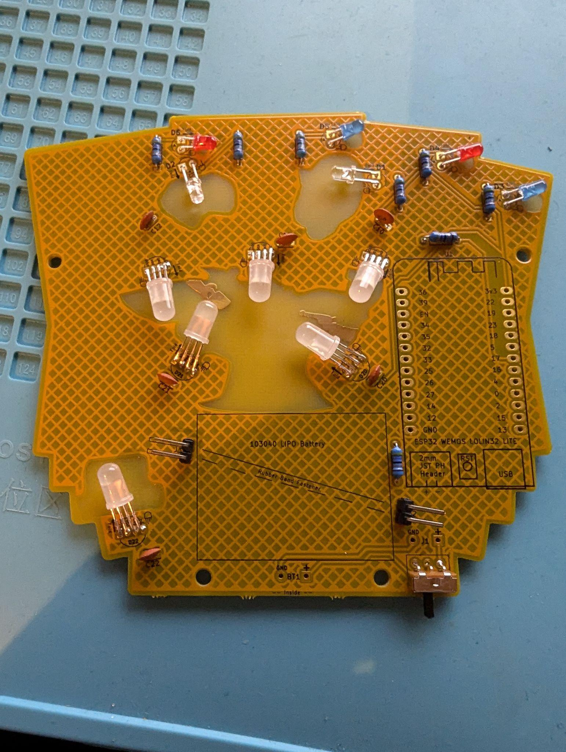

12. Use the 13 pin strings to connect the dev board to the PCB. The short side of them should go into the PCB, and the longer side goes into the dev board.

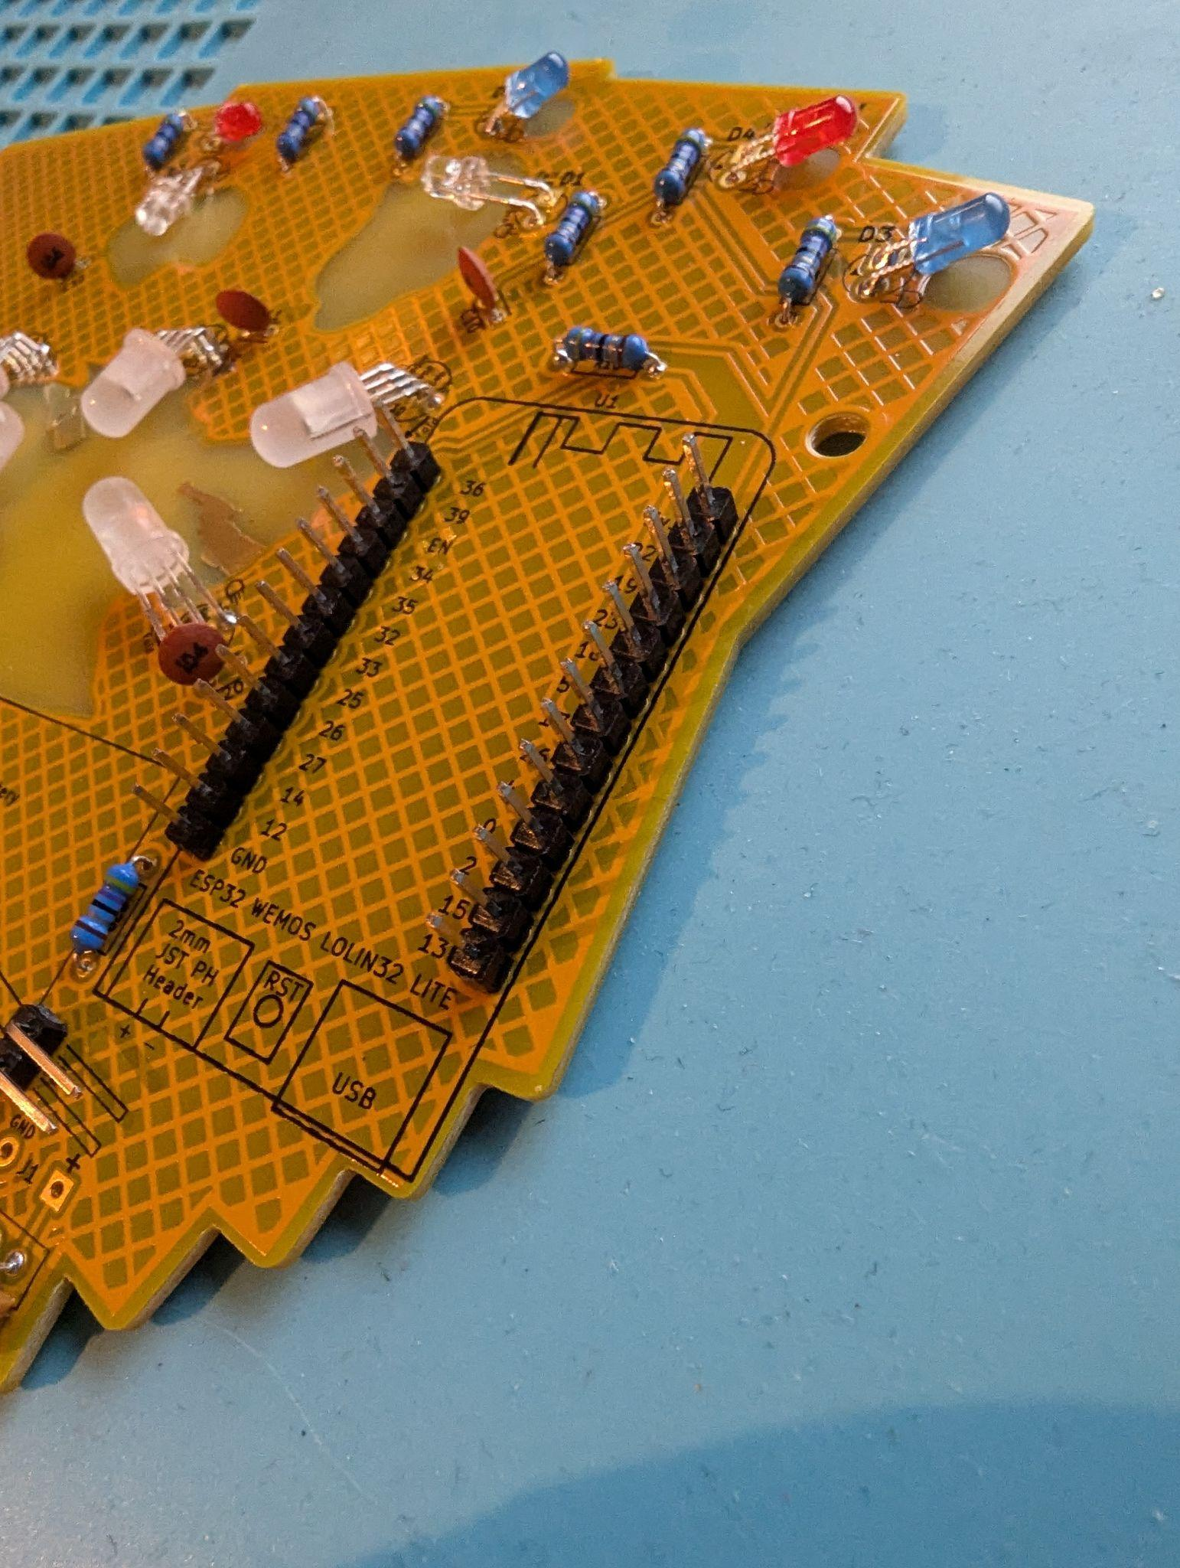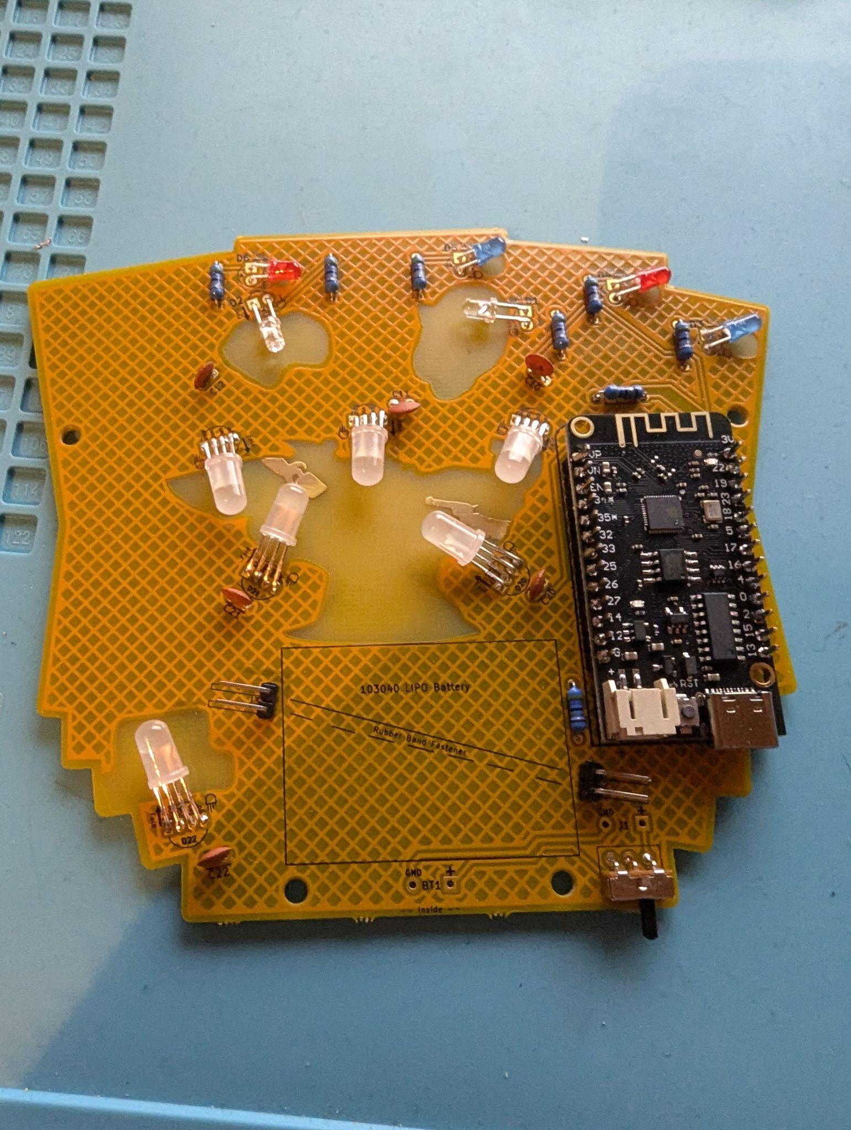

13. Put the two red and black wires into the board, following ground to ground and + to + they are labeled. After trimming the cover of the wire, you might have to twist the wires to get them into the holes.

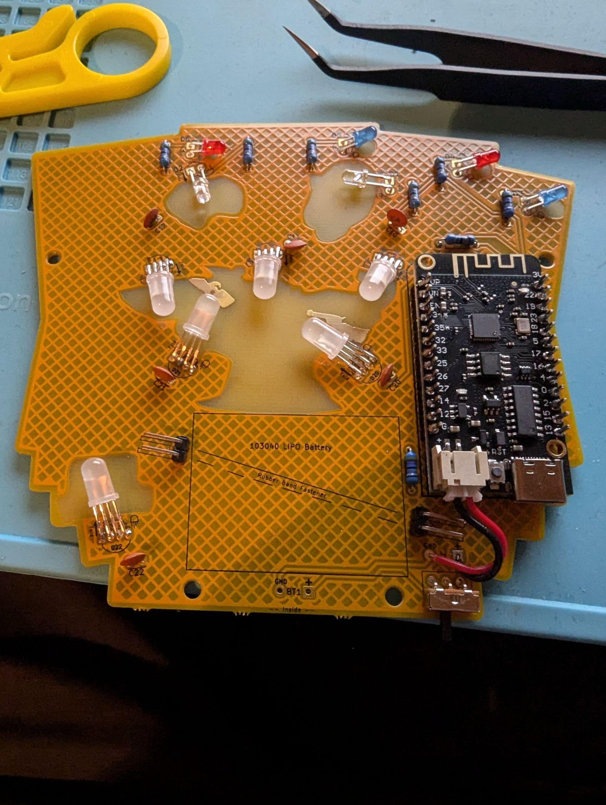

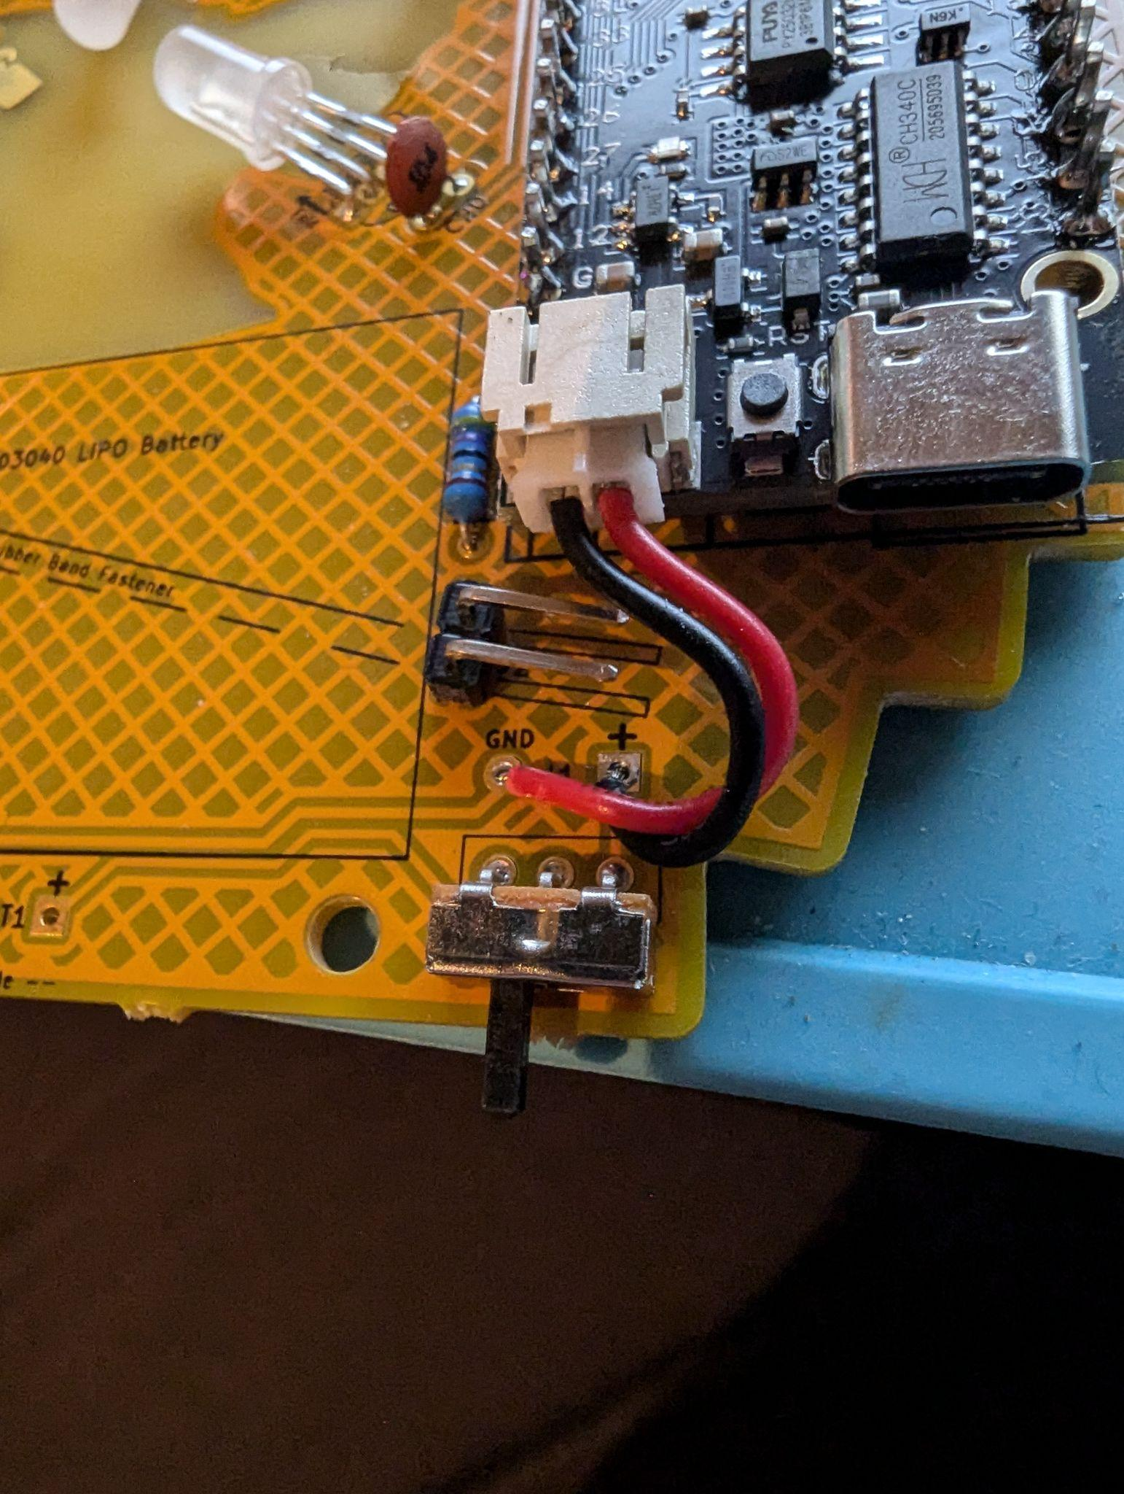

14. The battery is live, so with the text on the battery visible and the leads to the left, strip the wires one at a time and then solder. The off position for the power switch is towards the center of the badge.

15. Attack the rubberband to secure the battery.

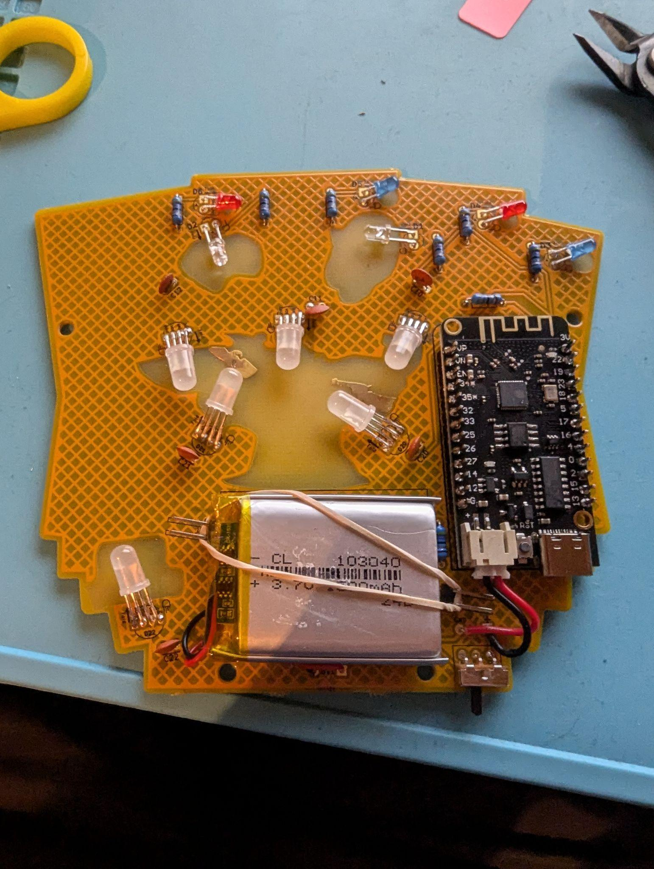

16. Screw the plates together and it's all done.

17. Test your badge and enjoy your new creation.